**Prerequisite**

CPU 2GHZ or above, RAM 8GB or above

.NET 4.7.1 Framework or above

IIS Express With 32 Bit/64 Bit

**Step 1:**

**Download & Extract**

Open Cover<https://github.com/OpenCover/opencover/releases/download/4.7.922/opencover.4.7.922.zip>

Generate Report

<https://github.com/danielpalme/ReportGenerator/releases/download/v4.2.5/ReportGenerator_4.2.5.zip>

**Step 2:**

**Configure applicationhost.config with your .net project/web application location. Sample is provided below as attachment**



**Option 1**: You can configure default applicationhost.config which will be in location %userprofile%\documents\IISExpress\config

**Option 2**: If you have created, you own applicationhost.config you should pass that has parameter for open cover command line

**Note**: It is recommended to use Option 2. If you’re using option 1 please take backup of applicationhost.config.

More info refers below

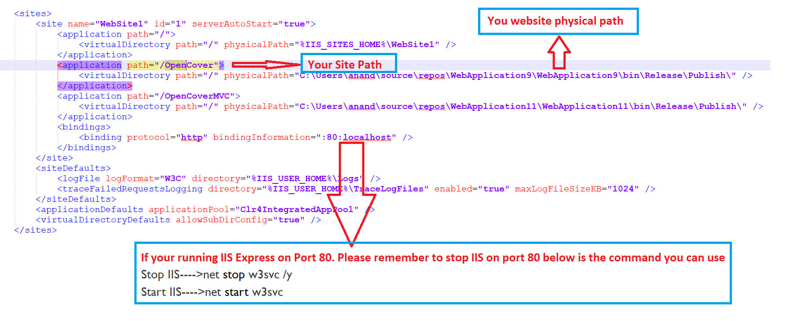

**Step 3: Run Open Cover Command**

**Before executing below command, make sure you need to switch location on command prompt where you have extracted Open Cover folder**

OpenCover.Console.exe -target:"C:\Program Files\IIS Express\iisexpress.exe"   
-targetargs:"-config:<Your Folder Path of applicationhost.config>"   
-filter:+[*]*   
-register:user   
"-searchdirs:<Your Folder Path for Bin>;<Your Folder Path for Bin>"

Example Code:

OpenCover.Console.exe -target:"C:\Program Files\IIS Express\iisexpress.exe" -targetargs:"-config:C:\MyFolder\Demo\applicationhost_aspx.config" -filter:+[*]* -register:user "-searchdirs:C:\MyFolder\Demo\aspx\bin;C:\MyFolder\Demo\mvc\bin"

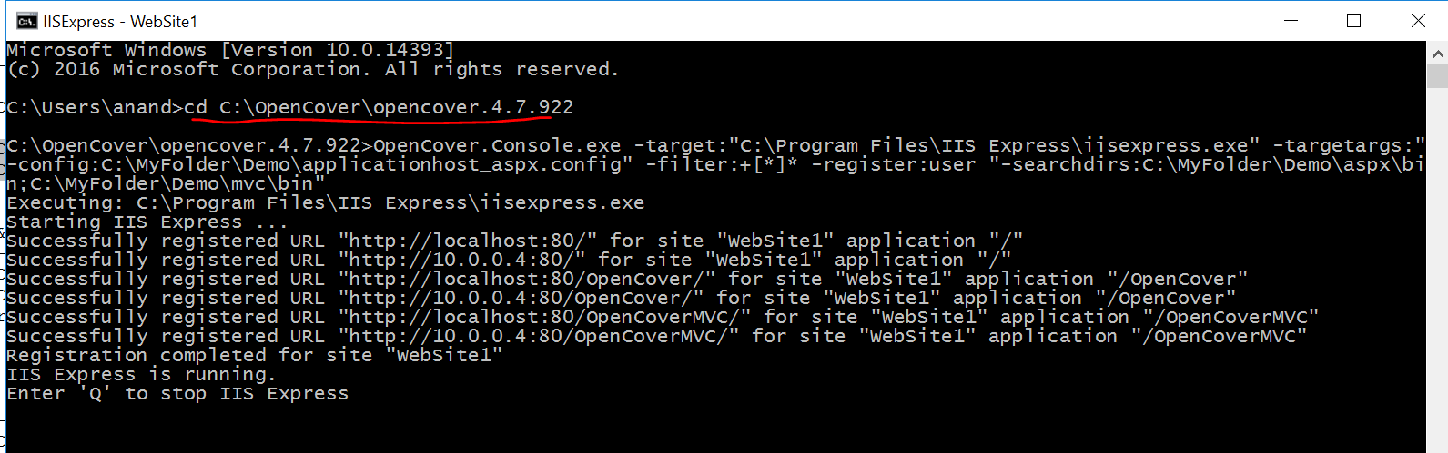

**Note:**

Please do use opencover parameter as it is -register:user **NOT LIKE -register:anand**

**Step 4: Once you run above Open cover command**

You should be able to access web site/app which you have configured in applicationhost.config. Please do the testing on web site/app so that open cover capture all the request event along with code coverage.

Once done with testing please **press ‘Q’** so that it generate report in path you have extracted Open Cover and it will be named **result.xml**.

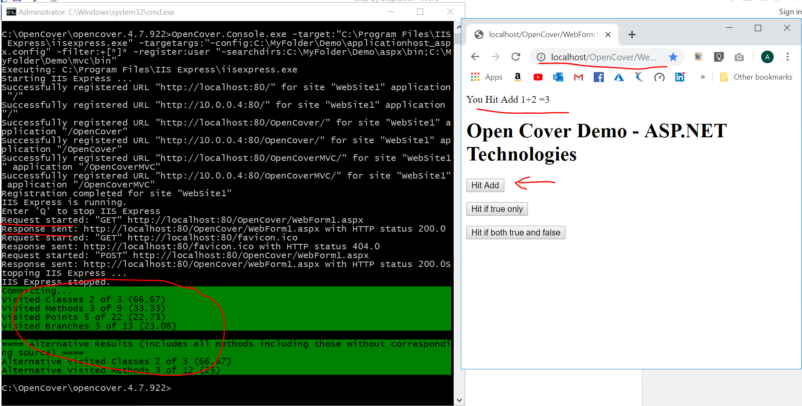

**Step 5: Generate Report Command**

**Before executing below command, make sure you need to switch location on command prompt where you have extracted Report folder**

ReportGenerator.exe -reports:"<Your Folder Path Of OpenCover Result.xml>"   
-targetdir:"<Folder Path To Output Reports>"   
-sourcedirs:<Your Folder Path for Bin>;<Your Folder Path for Bin>"   
"-assemblyfilters:-<Ignore Assemblies>" "-classfilters:-<Ignore Class filefilters>"   
"-filefilters:-<Ignore file path>*"

Example Code

ReportGenerator.exe -reports:"C:\OpenCover\opencover.4.7.922\results.xml" -targetdir:C:\MyFolder\Demo\zfunctionalCoverageReport "-sourcedirs:C:\MyFolder\Demo\aspx\bin;C:\MyFolder\Demo\mvc\bin" "-assemblyfilters:-Antlr3.Runtime*;-System.Web.UI.dll*" "-classfilters:-__ASP.FastObjectFactory*;-*.BundleConfig;-*.FilterConfig;-*.RouteConfig;-*.MvcApplication;-ASP._Page_Views__ViewStart_cshtml" "-filefilters:-C:\MyFolder\TFS\rmy\POC\OpenCover\aspx\*"

**Note**: Please use assembly/class/file filter generate report as per your need. For example open cover include Antlr3.Runtime assemblies which are not required as part of functional test coverage

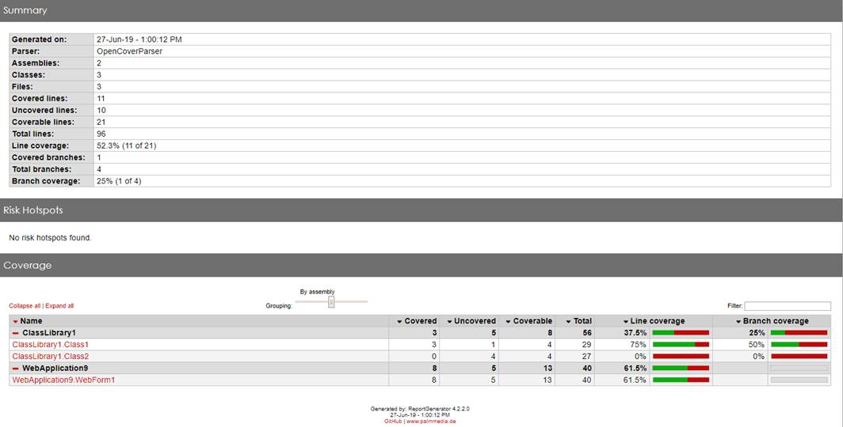

**Most Asked FAQ**

**Why we are using IIS Express why not Windows IIS?**

First thing first, we have done this research work based on keeping in mind all the projects and should be uniform across all projects.

1. Few of the team member don’t have admin privileges to run IIS or even not installed
2. IIS is tightly integrated with Windows OS where user and app pool should be configured properly as per project which is technical overhead.
3. If projects need to enable 32 bit then we can’t run explicit w3wp.exe in 32 bit since by default it runs with 64 bit when you running on 64 bit OS. Please note that technically we could do that using windows sdk installed tools but still in order to maintain uniform across all project we recommend to use IIS Express